A MINOR PROJECT REPORT ON

**“LIBRARY DATABASE MANAGEMENT SYSTEM”**

**Submitted**

*In the partial fulfillment of the requirements for*

*the award of the degree*

**BACHELOR OF TECHNOLOGY**

In

**COMPUTER SCIENCE & ENGINEERING**

|  |  |
| --- | --- |
|  | By |
| Radhika.K | 181FA04221 |
| R.Pratyusha | 181FA04222 |
| R.Shivani | 181FA04229 |
|  | Under the guidance of |

**Ms Bhavya Sree,** Assistant Professor

**DEPARTMENT OF COMPUTER SCIENCE &ENGINEERING**

**VIGNAN’S FOUNDATION FOR SCIENCE,TECHNOLOGY AND RESEARCH UNIVERSITY**

**(Accredited by NACC “A” grade)**

**Vadlamudi, Guntur.**





**ABSTRACT**

The Library Management System is an application for assisting a librarian in managing

a book library in a university. The system would provide basic set of features to add /

update members ,add/update books, and manage check in specifications for the

system based on the client’s statement of need.

Library management system is a typical management information system(MIS),

Its development includes the establishment and maintenance of a back-end

database and front-end application development aspects. For the former require the

establishment of data consistency and integrity of the strong data security and good

libraries. As for the latter requires the application fully functional, easy to use and

so on.

**CONTENT: page no:**

1. Introduction 6
   1. DBMS introduction
   2. Project introduction
   3. Project introduction
2. System Requirements 7
3. Data Requirements 8-9

3.1 entities

3.2 attributes

3.3 relationship – cardinality

4. Entity – Relationship Diagram 10

5. Relationship Model Introduction 11-12

5.1 Conversion of E.R. diagram to relational

model

6.Source Commands 13-18

7. Sample Tables 18-23

8.output screenshots 24-26

9.Conclusion 27

10.References 27



**LIBRARY DATABASE**

**MANAGEMENT SYSTEM**

1. **INTRODUCTION**

1.1 DBMS introduction :

The main aim of a DBMS is to supply a way to store up and retrieve database information

that is both convenient and efficient. By data, we mean known facts that can be recorded and that have embedded meaning. Normally people use software such as DBASE IV or V, Microsoft ACCESS, or EXCEL to store data in the form of database. A datum is a unit of data. Meaningful data combined to form information. Hence, information is interpreted data - data provided with semantics. MS. ACCESS is one of the most common examples of database management software.

1.2 Project Introduction :

A college library management is a project that manages and stores books information electronically

according to students needs. The system helps both students and library manager to keep a constant

track of all the books available in the library. It allows both the admin and the student to search for

desired book. It becomes necessary for colleges to keep a continuous check on the books issued and returned and even calculate fine. This task if carried out manually will be tedious and includes chances of mistakes. These errors are avoided by allowing the system to keep track of information such as issue date, last date to return the book and even fine information and thus there is no need to keep manual track of this information which thereby avoids chances of mistakes.  
Thus this system reduces manual work to a great extent allows smooth flow of library activities by removing chances of errors in the datails.

1.3 Project Advantages :

The web based Library Management System is very important in the present scenario to deliver content and resources to students, faculty and staff. All the details of the books such as author name, edition, etc, can be managed with our online solution .**Advantages of Our Campus Library Management System.**  
All the educational institutions should know following advantages of the Library Management System:

* **Record Maintenance**
* **Web-Based Solution**
* **Saves Time and Cost**
* **Secure and Reliable**
* **Increases Efficiency**
* **Simple and Easy to Use**

1. **SYSTEM REQURIEMENTS:**

We will focus on the following set of requirements while designing the Library Management System:

1. Any library member should be able to search books by their title, author, subject category as well by the publication date.
2. Each book will have a unique identification number and other details including a rack number which will help to physically locate the book.
3. There could be more than one copy of a book, and library members should be able to check-out and reserve any copy. We will call each copy of a book, a book item.
4. The system should be able to retrieve information like who took a particular book or what are the books checked-out by a specific library member.
5. There should be a maximum limit (5) on how many books a member can check-out.
6. There should be a maximum limit (10) on how many days a member can keep a book.
7. The system should be able to collect fines for books returned after the due date.
8. Members should be able to reserve books that are not currently available.
9. The system should be able to send notifications whenever the reserved books become available, as well as when the book is not returned within the due date.
10. Each book and member card will have a unique barcode. The system will be able to read barcodes from books and members’ library cards.
11. **DATA REQUIREMENTS**

**3.1 ENTITIES:**

* BRANCH
* EMPLOYEE
* CUSTOMER
* ISSUE STATUS
* RETURN STATUS
* BOOKS

**3.2 ATTRIBUTES:**

* BRANCH
* Manager _id
* Branch _id
* Address
* Contact _no
* Branch _no
* Street
* City
* State
* Zip _code
* CUSTOMER
* Customer _id
* Books _issued
* Name
* Address
* Registration _date
* ISSUE STATUS
* Issue _book _name
* Issue _id
* Issue _date
* ISBN
* RETURN STATUS
* Return _id
* Return _date
* Customer _id
* Return _book _name
* ISBN
* BOOKS
* ISBN
* Title
* Category
* Rental _price
* Author
* Publisher
* Status

**3.3 RELATIONSHIPS – CARDINALITY**

* MANAGER manages the BRANCH
* CUSTOMER registers in the respective BRANCH
* CUSTOMER issues BOOKS
* CUSTOMER returns BOOKS
* EMPLOYEE updates BOOKS

1. **ENTITY – RELATIONSHIP DIAGRAM:**

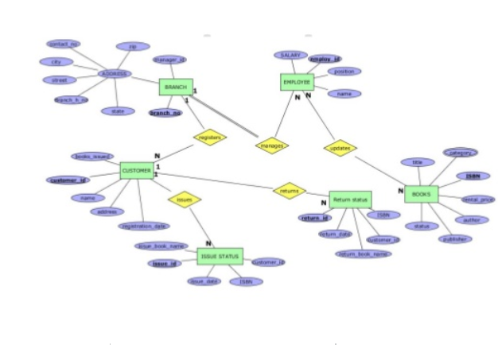

**5.RELATIONAL MODEL INTRODUCTION:**

The relational model represents the database as a collection of relations. A relation is nothing but a table of values. Every row in the table represents a collection of related data values. These rows in the table denote a real-world entity or relationship.

The table name and column names are helpful to interpret the meaning of values in each row. The data are represented as a set of relations. In the relational model, data are stored as tables. However, the physical storage of the data is independent of the way the data are logically organized.

Some popular Relational Database management systems are:

* DB2 and Informix Dynamic Server - IBM
* Oracle and RDB – Oracle
* SQL Server and Access - Microsoft

**Relational Model Concepts**

1. **Attribute:** Each column in a Table. Attributes are the properties which define a relation. e.g., Student _ Roll no. , NAME , etc.
2. **Tables** – In the Relational model the, relations are saved in the table format. It is stored along with its entities. A table has two properties rows and columns. Rows represent records and columns represent attributes.
3. **Tuples** – It is nothing but a single row of a table, which contains a single record.
4. **Relation Schema:** A relation schema represents the name of the relation with its attributes.
5. **Degree:** The total number of attributes which in the relation is called the degree of the relation.
6. **Cardinality:**Total number of rows present in the Table.
7. **Column:** The column represents the set of values for a specific attribute.
8. **Relation instance** – Relation instance is a finite set of tuples in the RDBMS system. Relation instances never have duplicate tuples.
9. **Relation key** - Every row has one, two or multiple attributes, which is called relation key.
10. **Attribute domain** – Every attribute has some pre-defined value and scope which is known as attribute domain.

**5.1 Conversion of ER Diagram to Relational model**

* **1) Mapping regular/strong entity**  
  For each strong entity set create a new relational independent table that includes all attributes as column. For composite attribute include only component attributes.
* **2) Mapping weak entity**  
  Convert every weak entity set into a table where we take the discrimination attribute of the weak entity set and takes the primary key of the strong entity set as a foreign key and then declared the combination of discriminator attribute and foreign key as a primary key.
* **3) Mapping 1:1 Relationship**  
  For a 1:1 Relationship between two entities **S** and **T**. Choose one of the relations, Example - **S** and include as foreign key in **S** the primary key of **T**. It is better to choose on entity total participation on **S** and include descriptive attribute.
* **4) Mapping 1:N Relationship**  
  For 1:N relationship identify the entity **S** on **N** side of the relationship. Include a foreign key in **S** the Primary key of relation **T** also include Discipline attributes of 1:N attribute of **S**.
* **5) Mapping N:N Relationship**  
  For each M:N relationship create a new relational table include in the new relation ,the primary key of the participating entities as a well as descriptive attributes. The primary key of the table will be the combination of primary keys of participating entities.
* **6) Mapping Multi-valued attribute**  
  For every multi-valued attribute will make a new table where we will take primary key of main table as a foreign key and multi-valued attribute as a primary key.

**SOURCE COMMAND:**

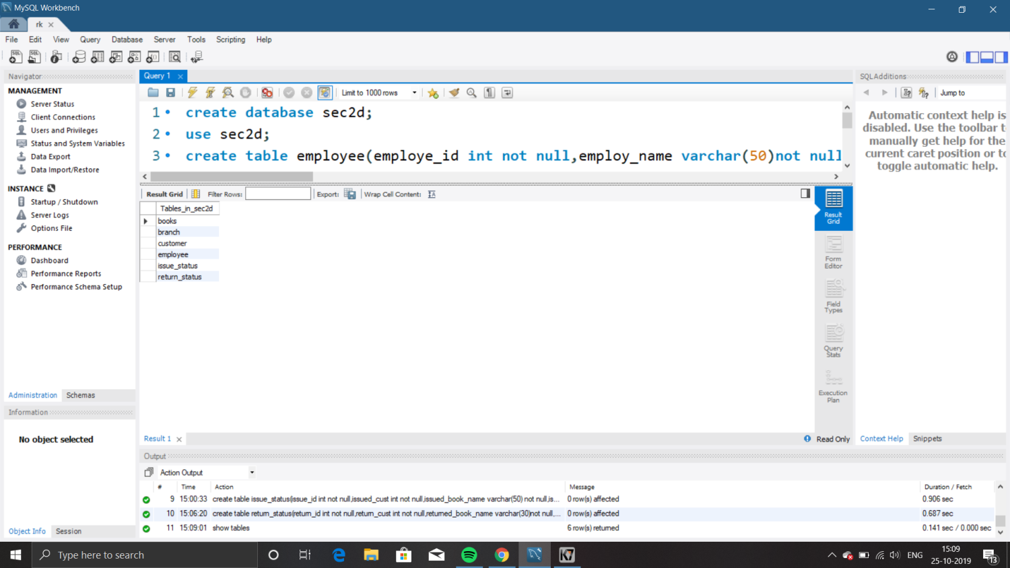

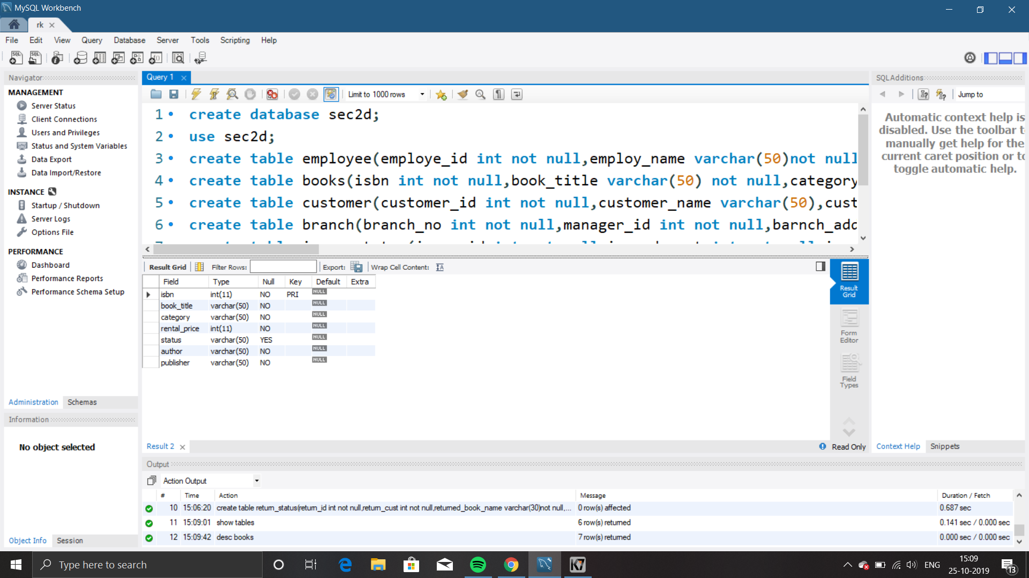

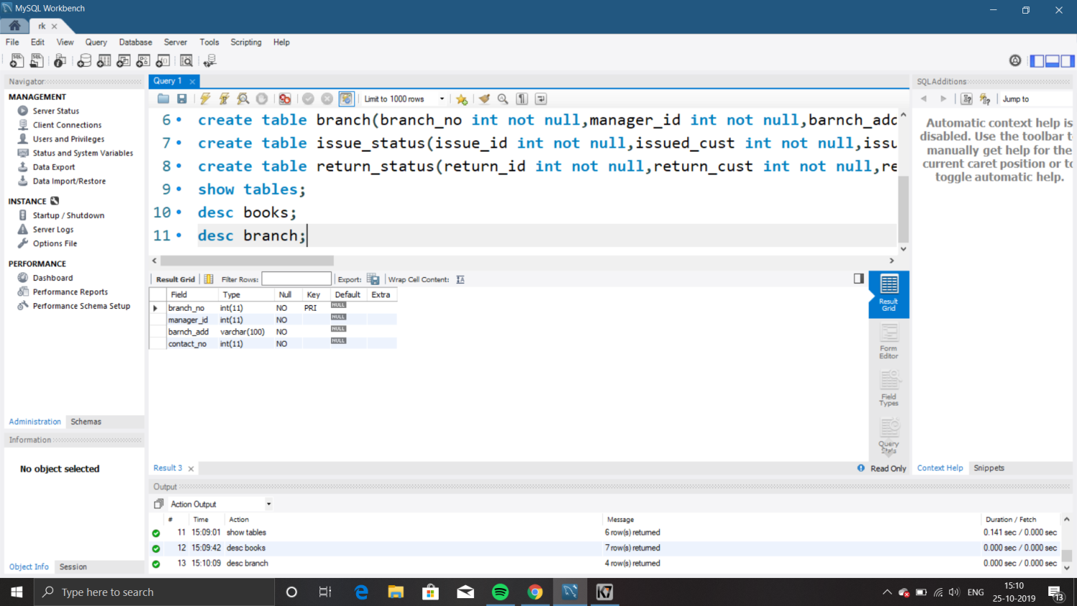

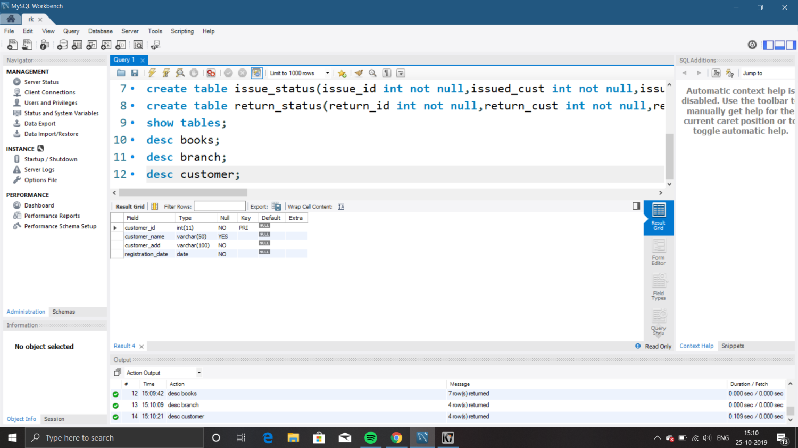

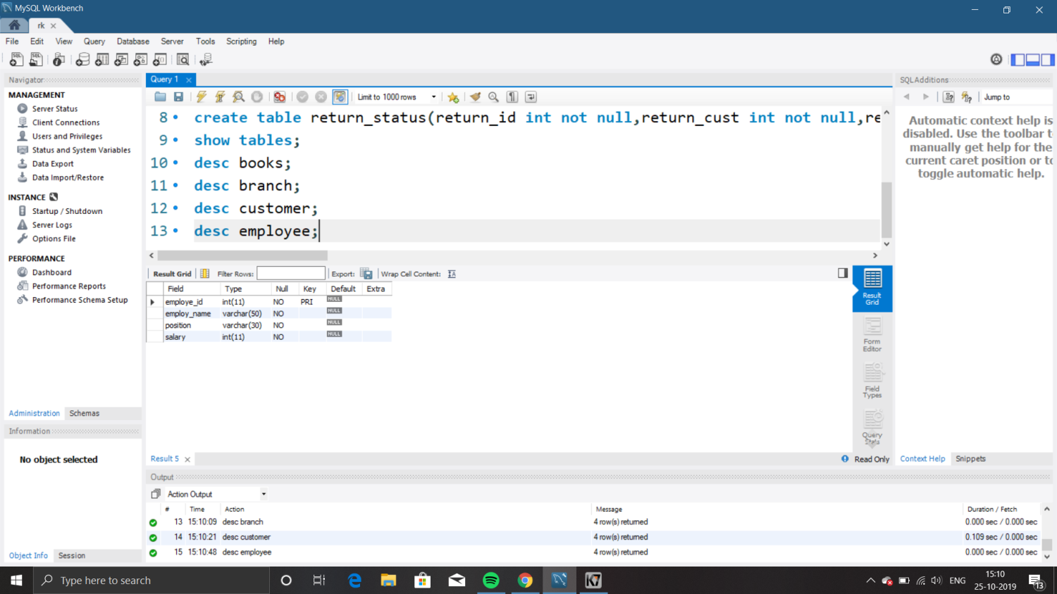

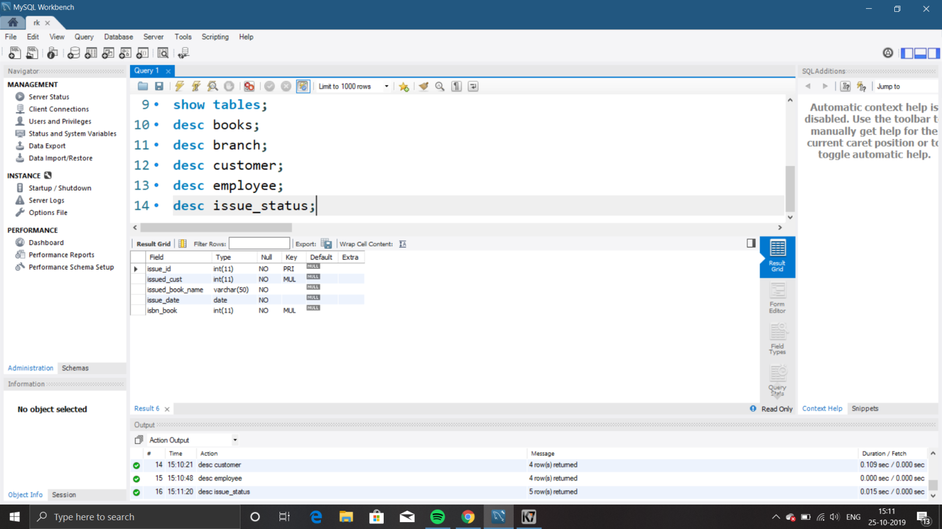

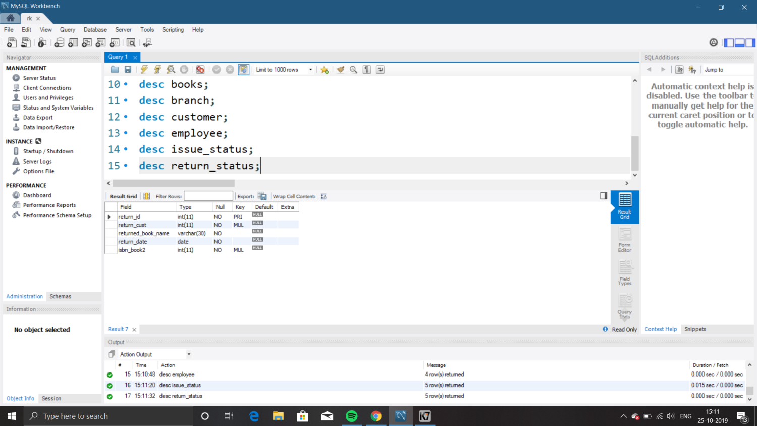

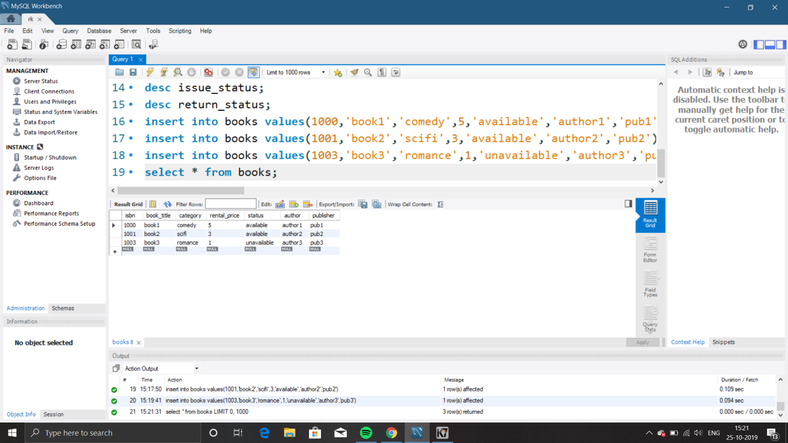

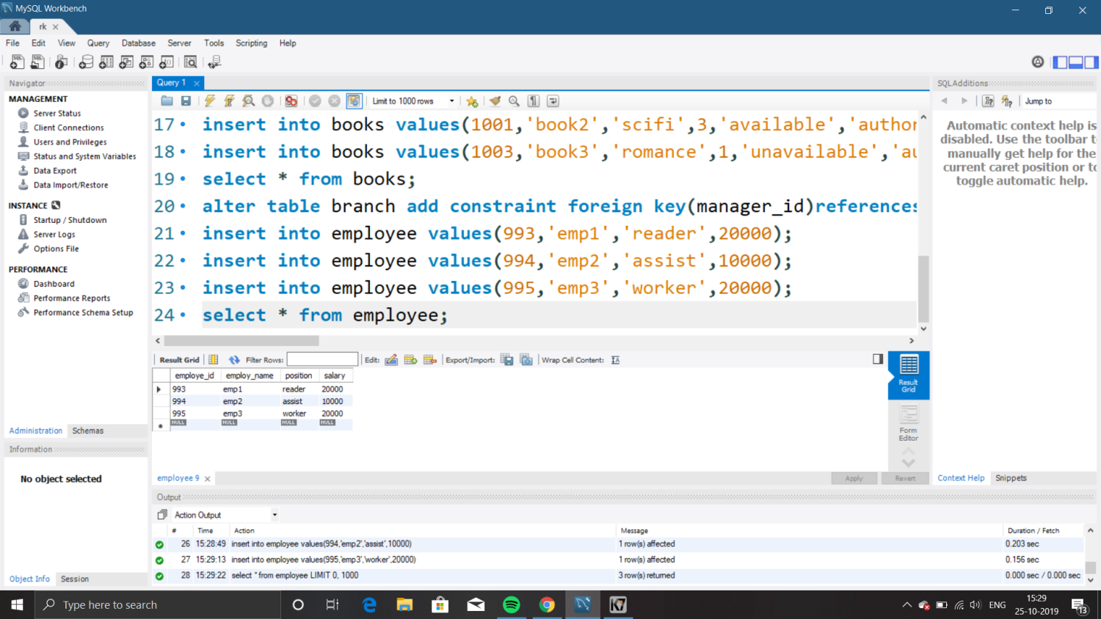

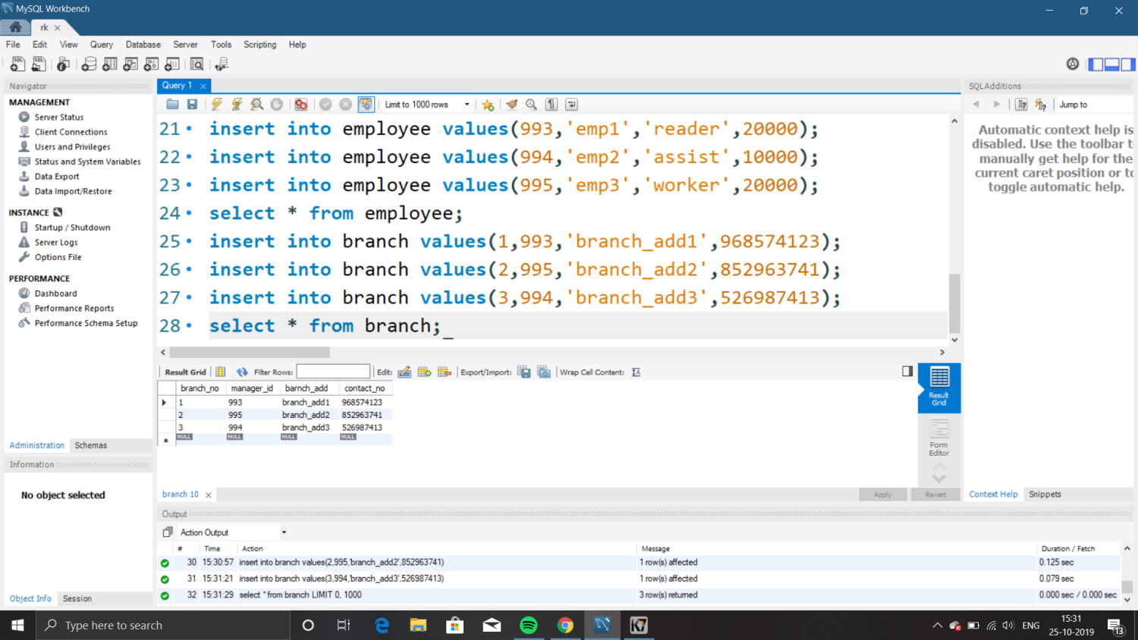

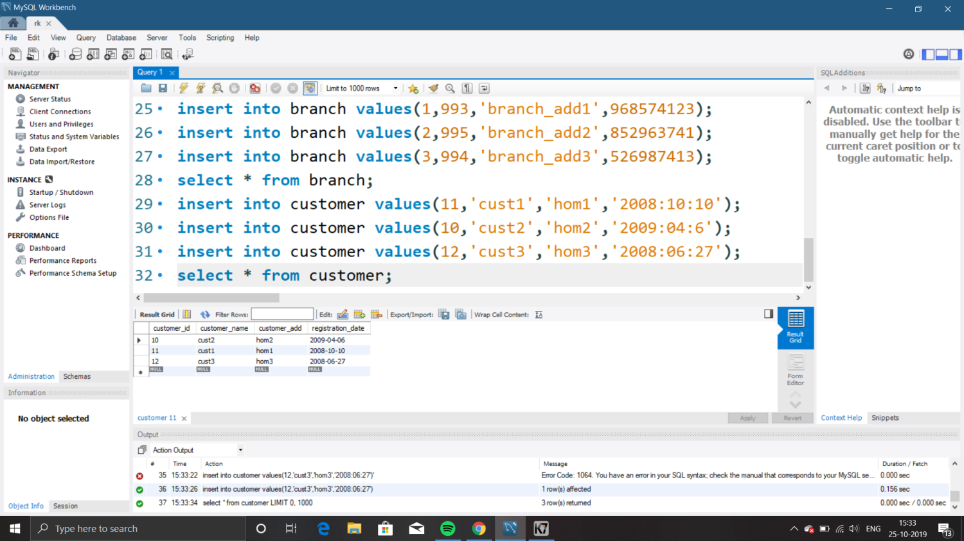

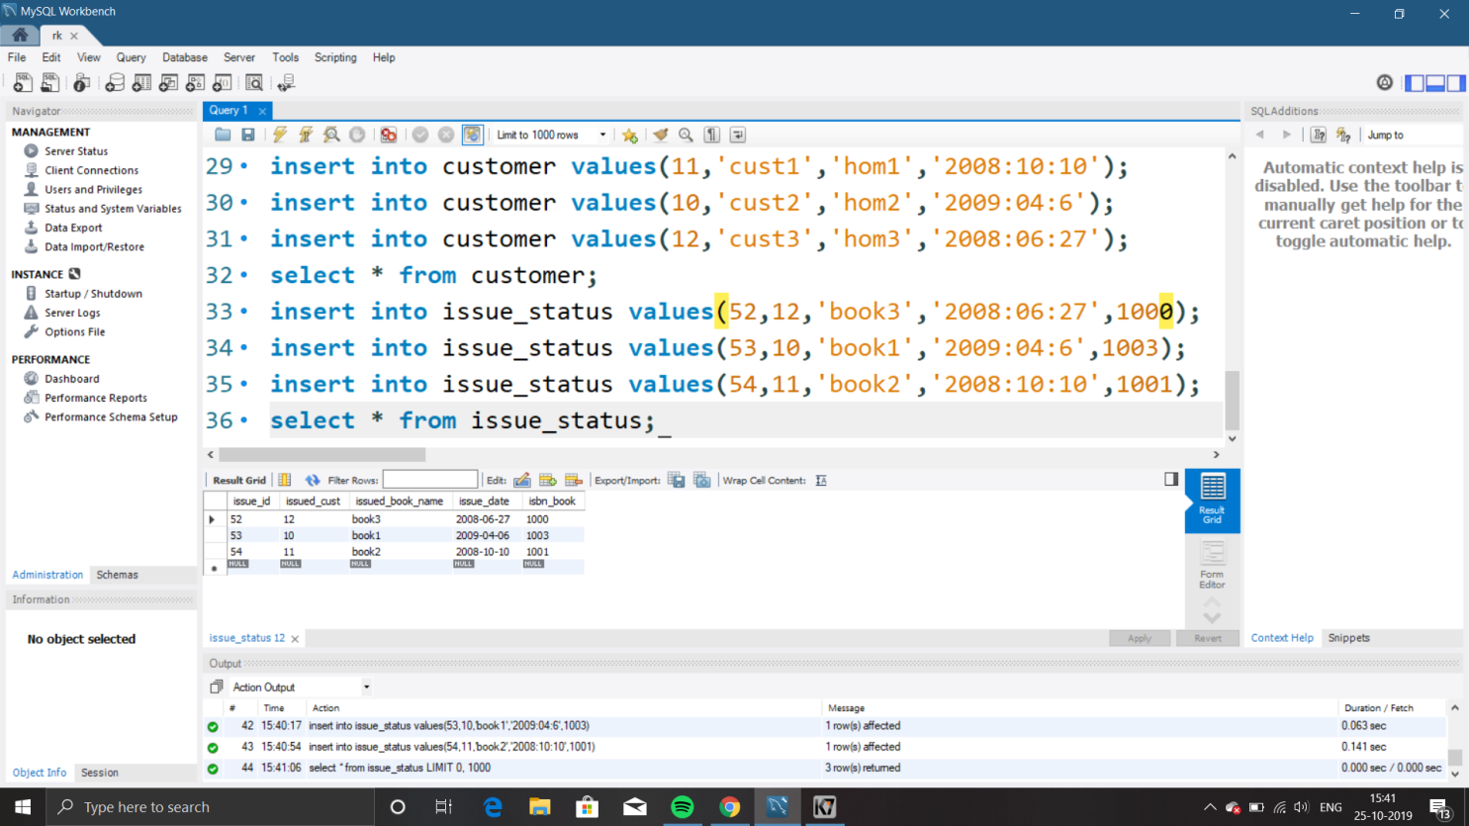

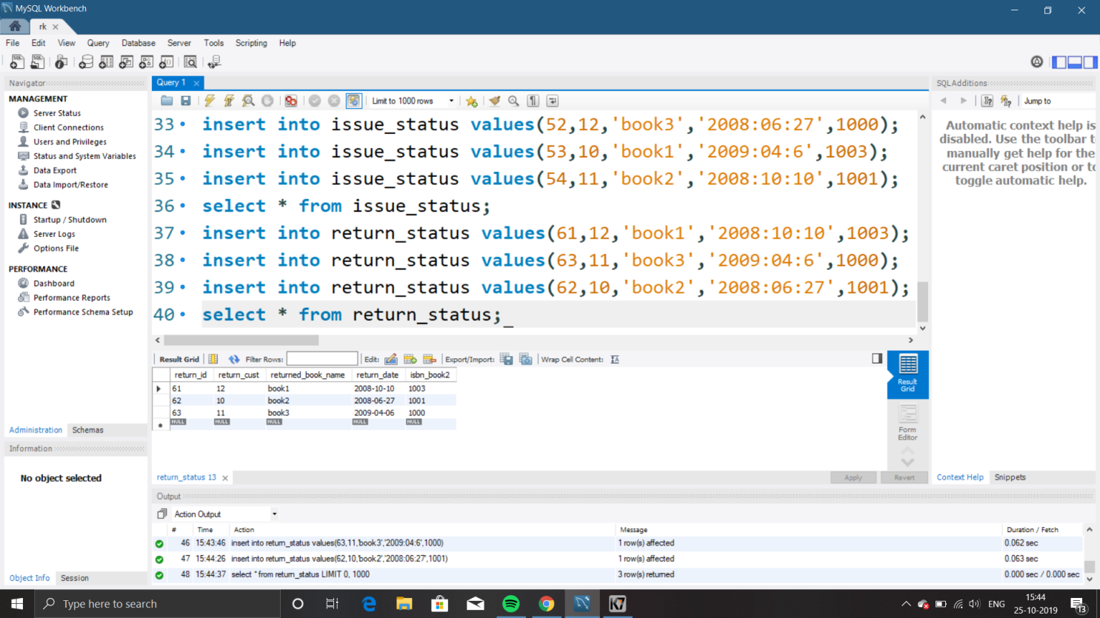

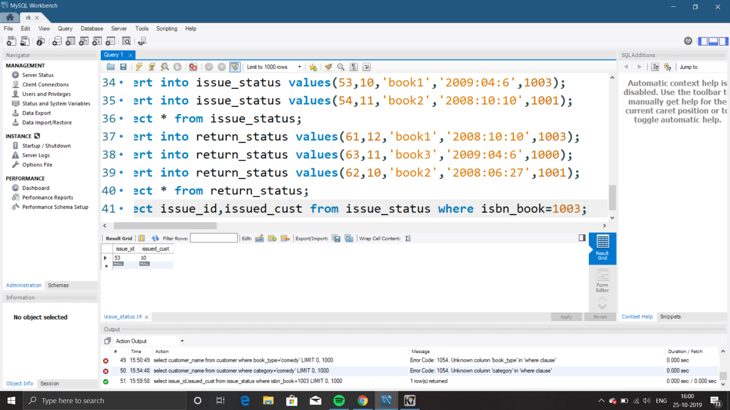

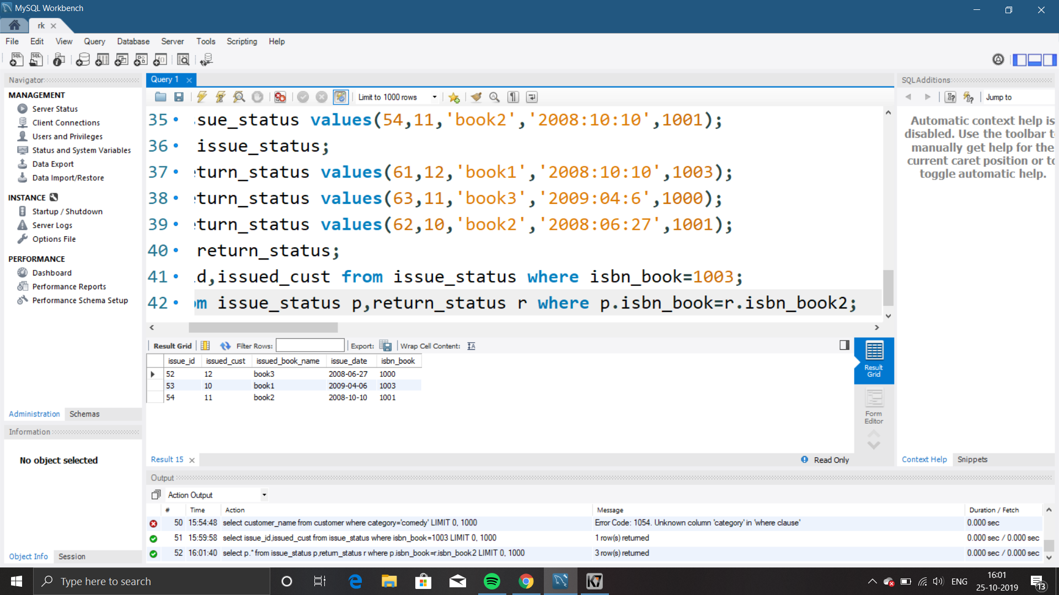

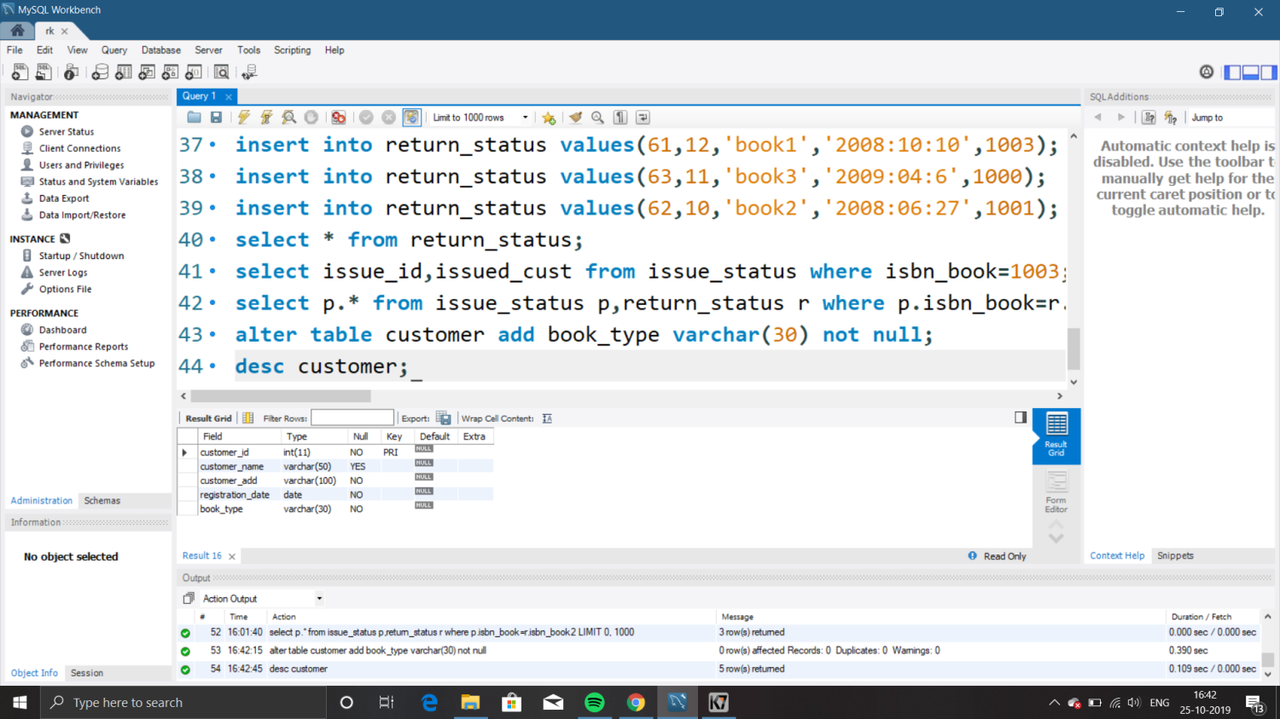

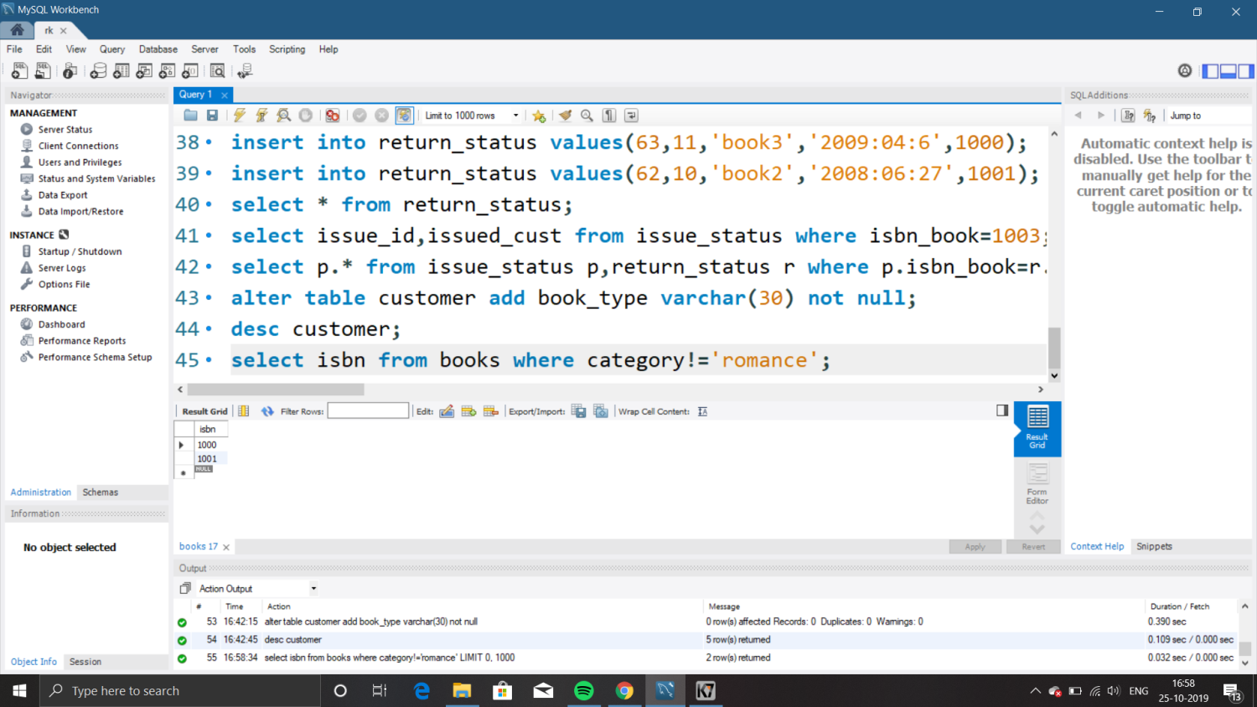

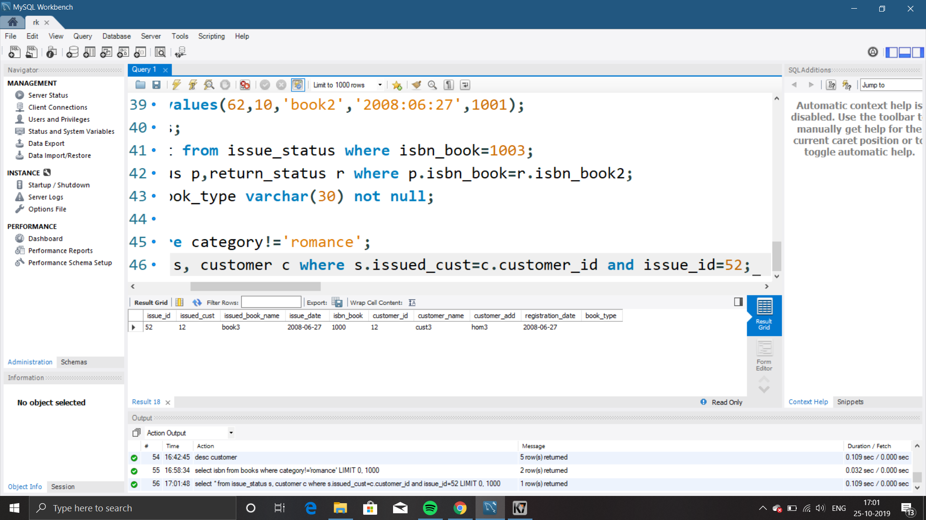

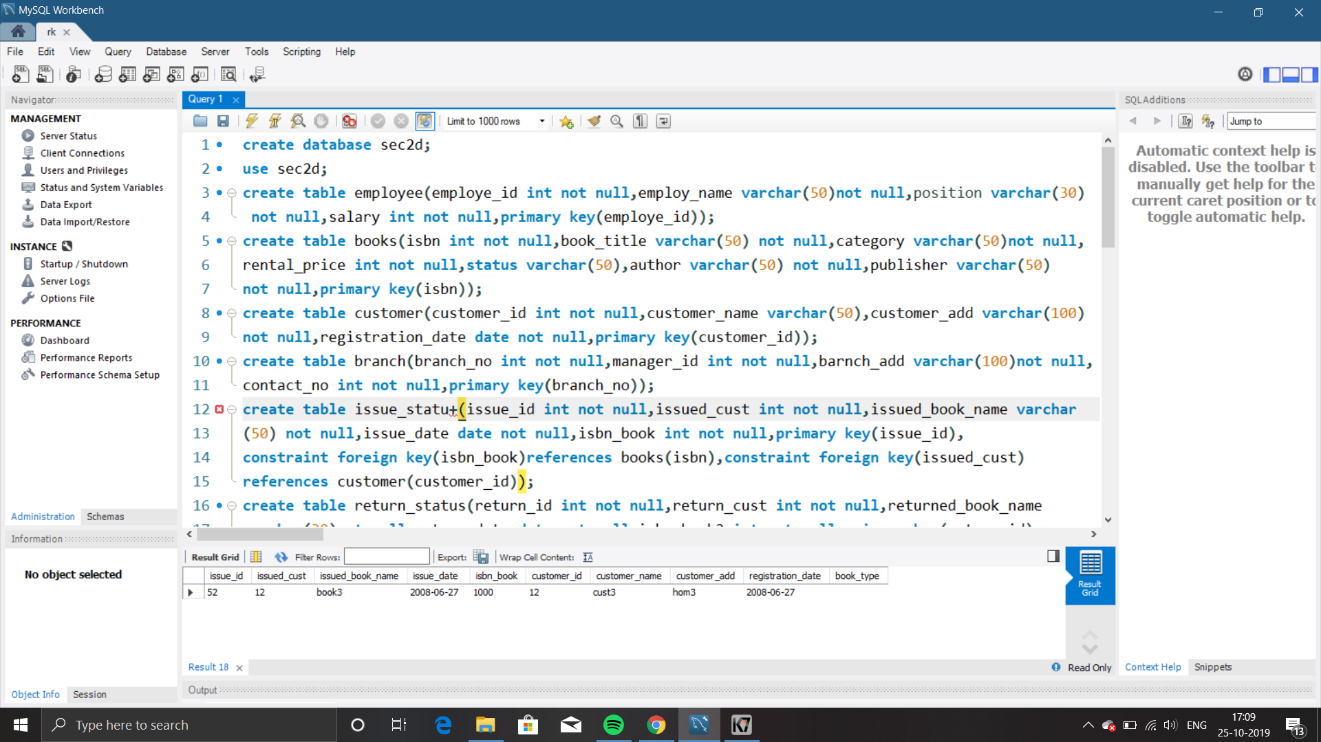

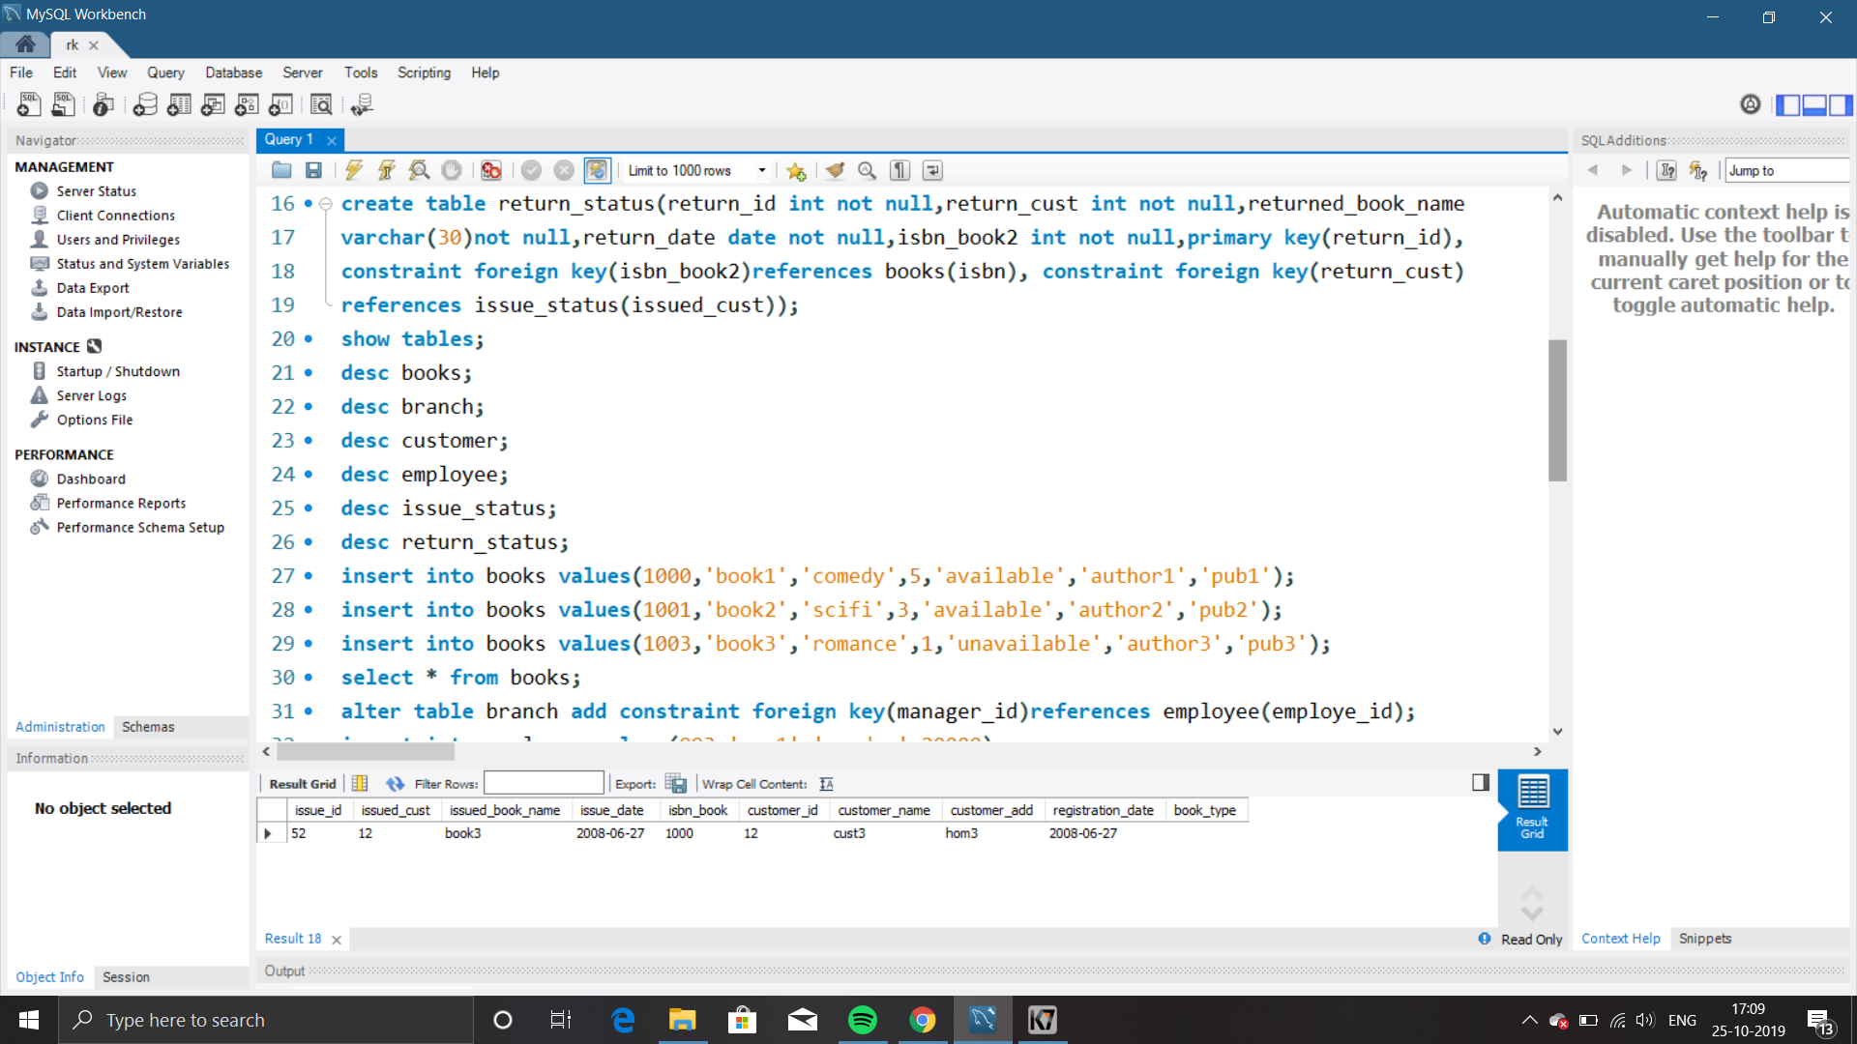

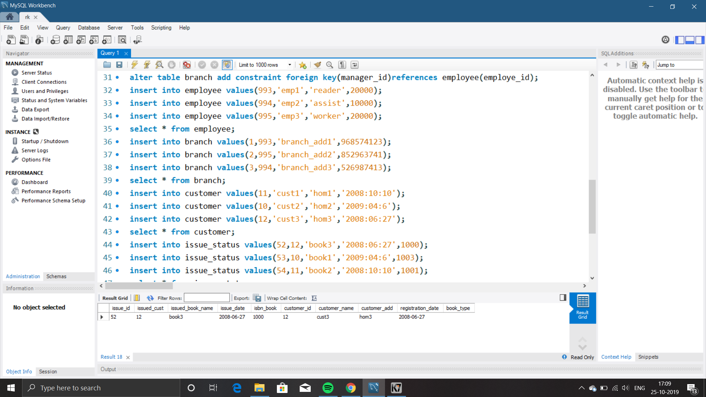

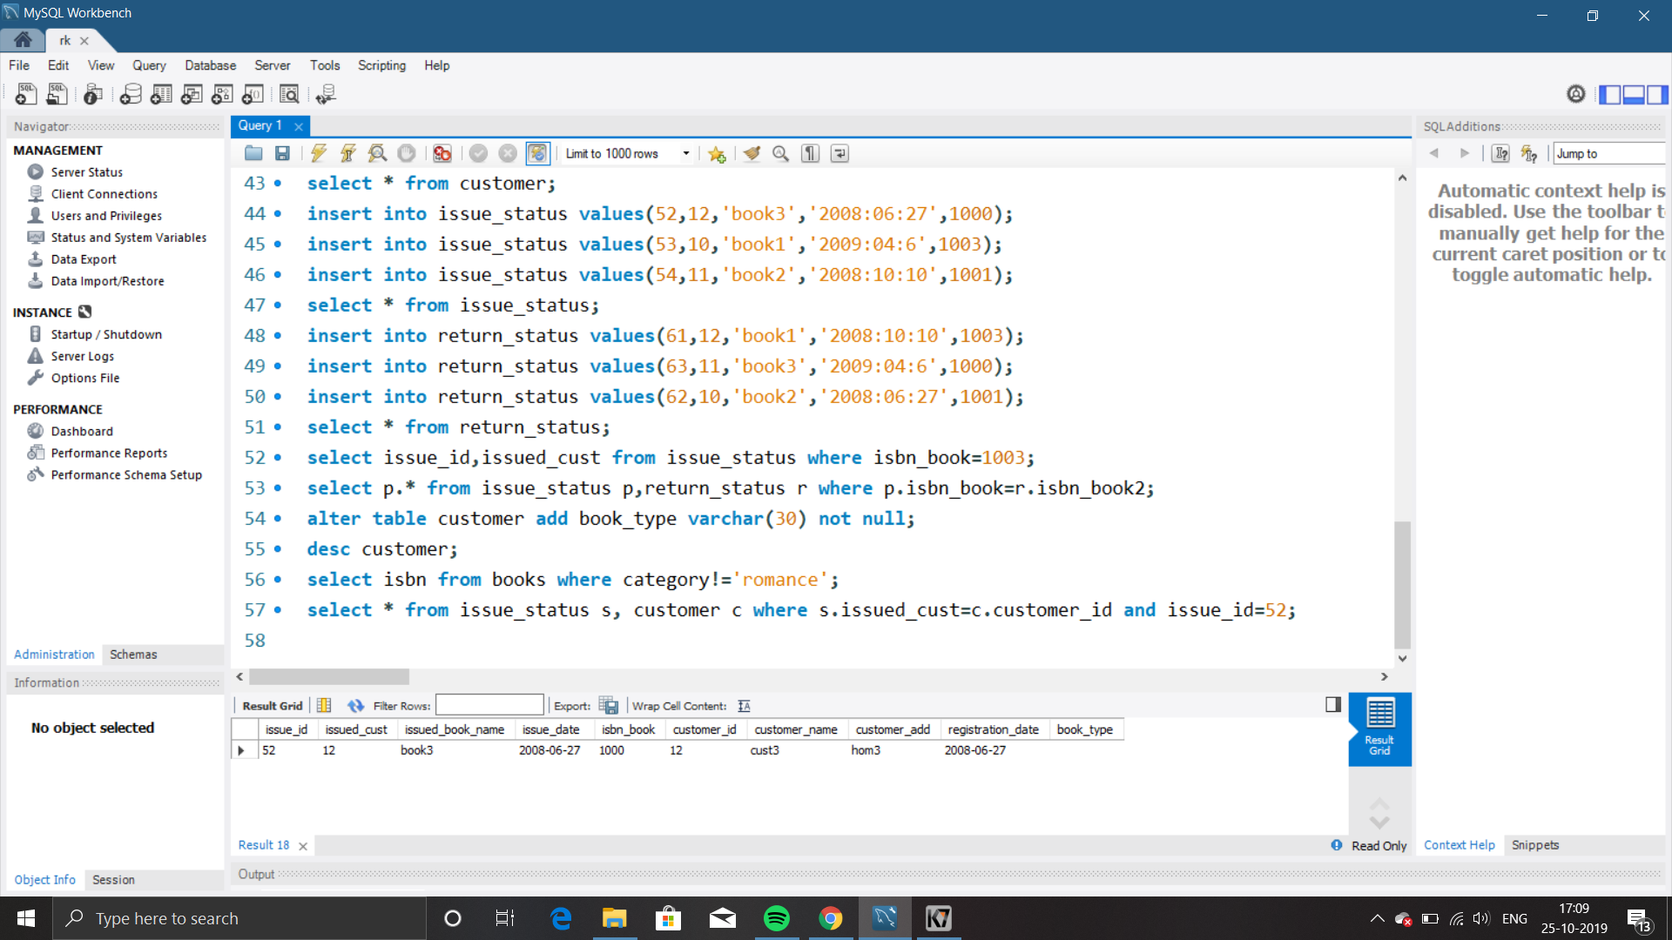

OUT PUT SCREENSHOTS:

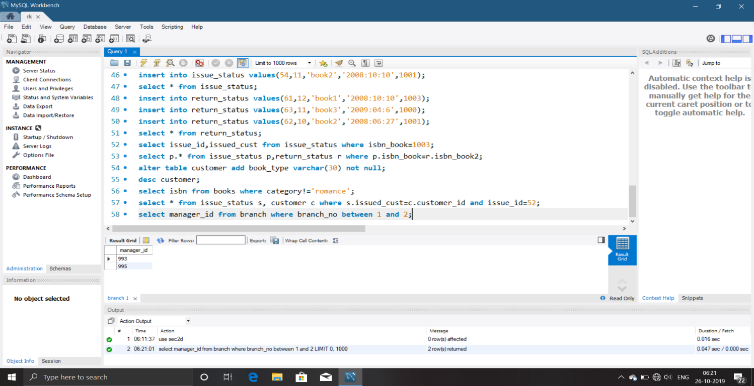

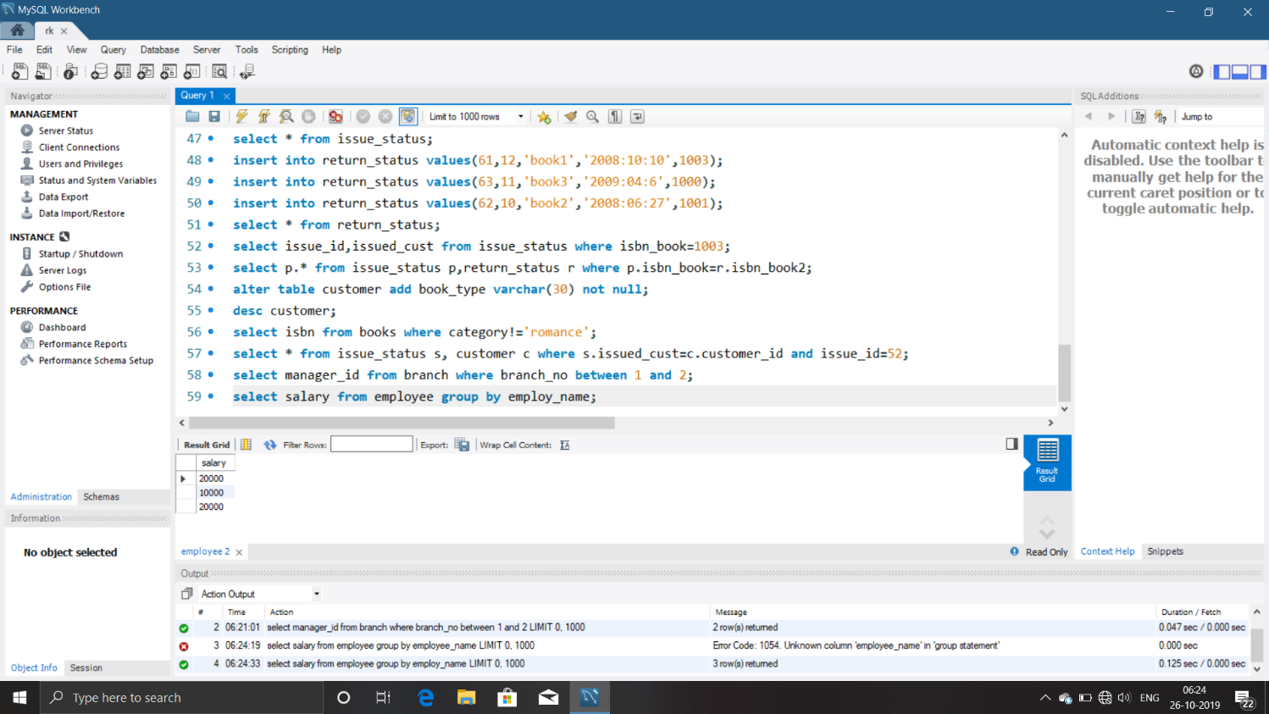

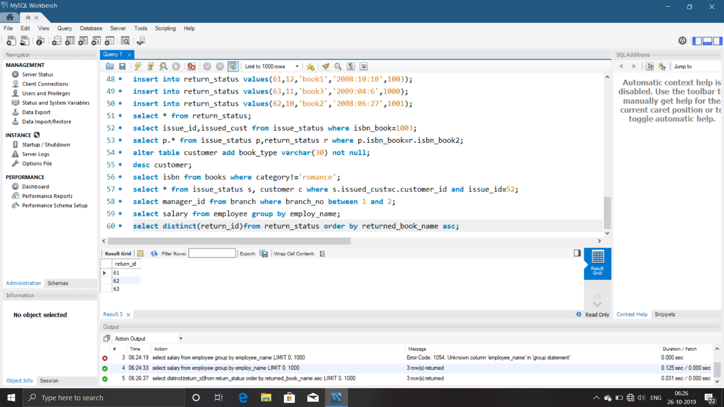

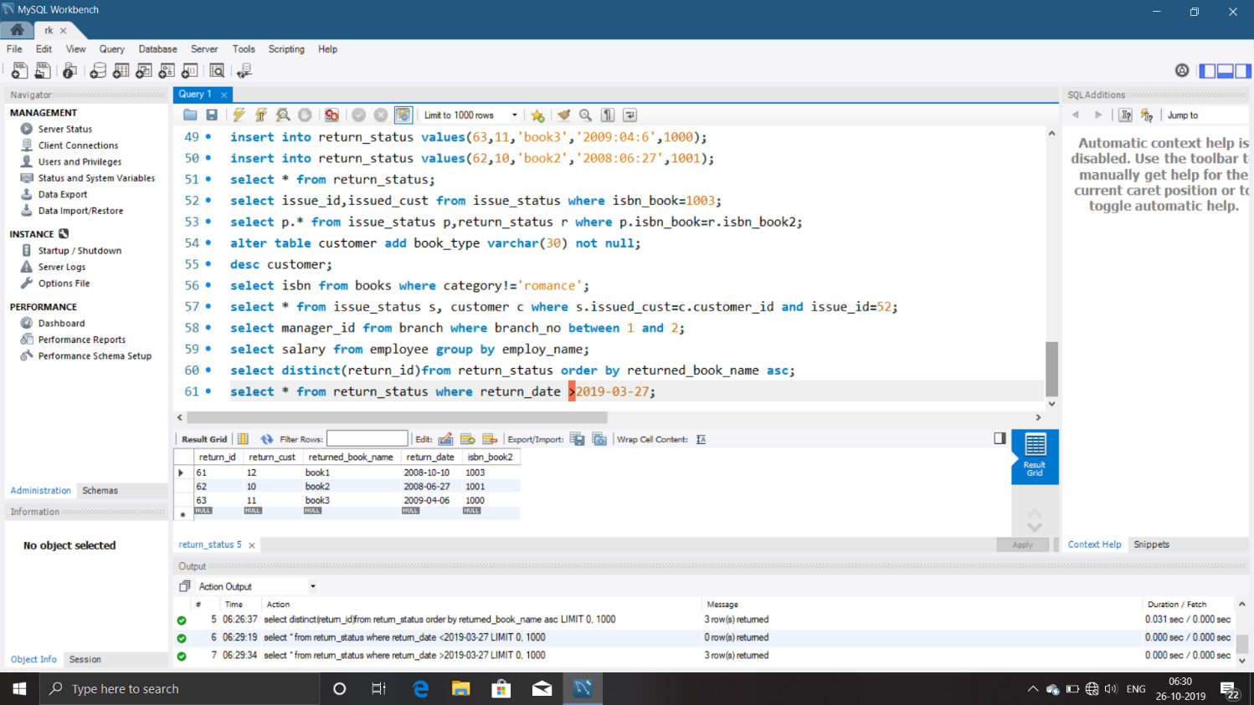

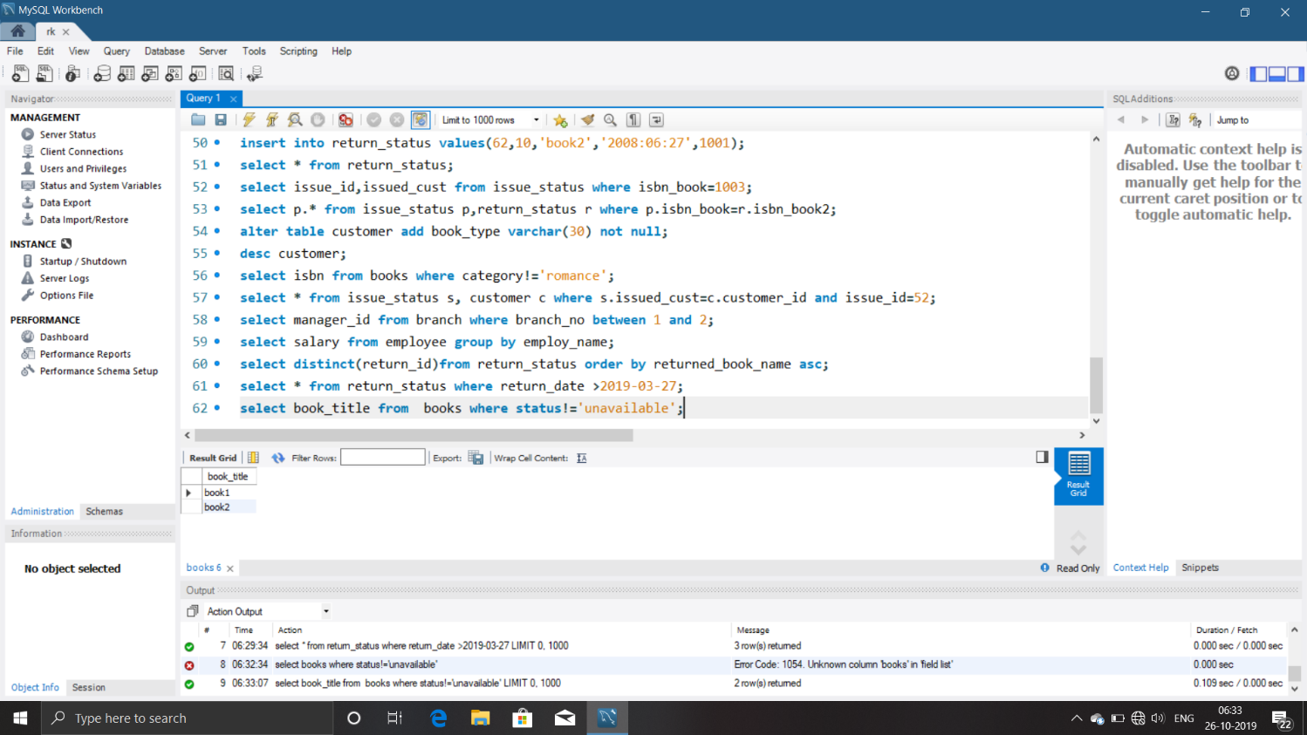

**CONCLUSION:**

* SQL database management application which is very well used in the modern world in organising and manipulating a database .
* Though SQL doesn’t have the GUI interface like Microsoft access is having and they all manage the database comfortable.
* Depending on the user or users , if an organisation has multiple users then they would go for SQL server based application.
* This project shows how to create tables in SQL and how to create simple data manipulation language and data definition language with how to execute them.
* It also shows how relationships are established with the concept of primary and foreign key within a table.
* Lastly, the project shows how queries are created in SQL server , queries like the create command ,view ,update , alter ,etc.

**REFERENCES:**

www.slideshare.in